Hadoop Framwork:

Let’s first understand the major components of Hadoop 1.0 architecture:

- Name Node
- Secondary name node
- Job Tracker
- Task Tracker
- Data Nodes

Once we understand Hadoop Architecture 1.0, it will be easier to understand the Hadoop Architecture 2.0. As of now ( 24 Nov 2019), there are three different version of Hadoop, out of which Hadoop V2 or YARN is the most stable one.

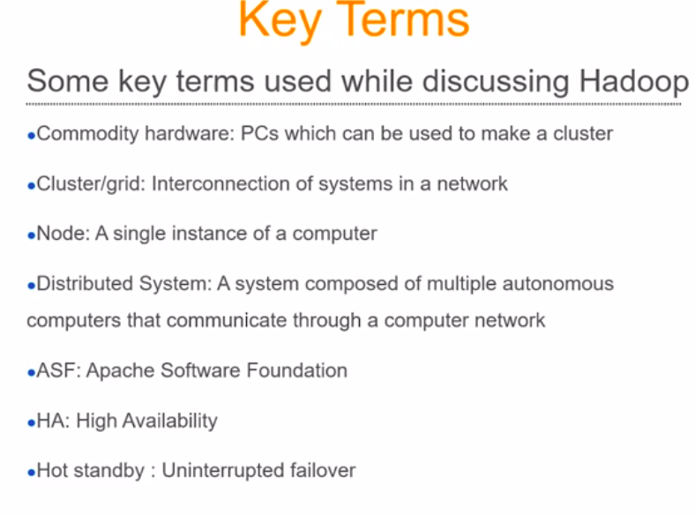

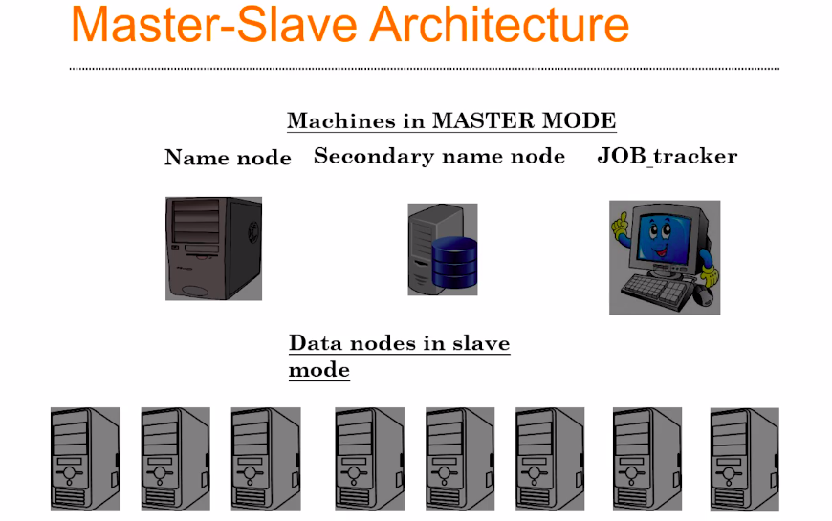

Let’s say you decided to have 10 machines into your cluster, in which 3 machines will always be working as masters. And the name of each server are Name Node, Secondary Name Node and a Job Tracker, these three are individual machine or individual servers in which Hadoop is running. These 3 machines will work in the master mode.

The remaining machines will work as a slave mode. Means, they will wait for instruction from the master, and these nodes are called as data nodes.

The Name Node, Secondary Node, Job Tracker, and Data Nodes will be interconnected by networking infrastructure, means they are not going to be interconnected by wifi routers, but by physical Ethernet cables or Fiber Optics for a high performance.

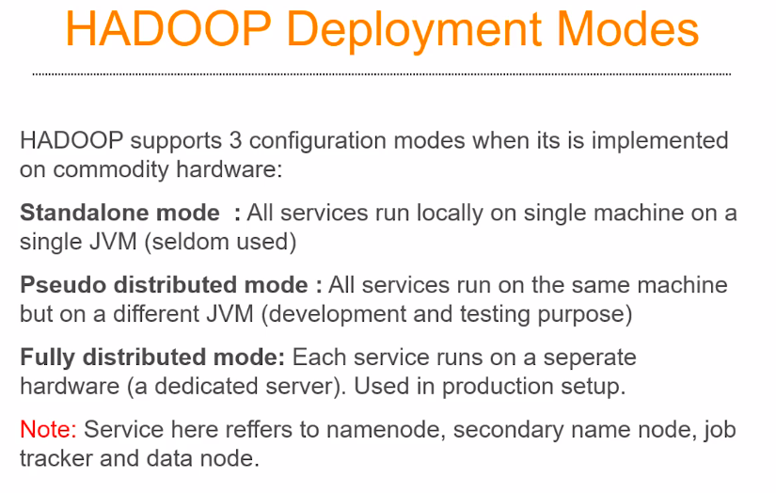

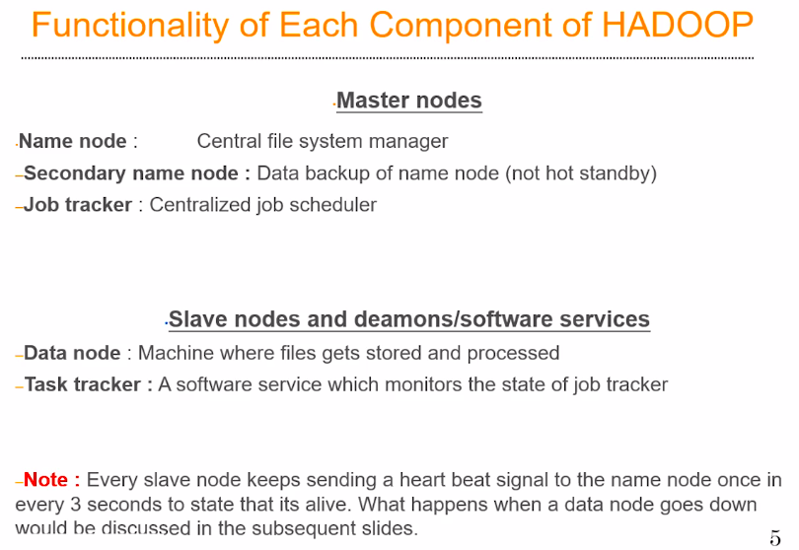

Hadoop is a parallel processing framework, so if you want to do some parallel processing we need to have a distributed file system.

Hadoop has its own built in distributed file system which is called as HDFS, which we’ll discuss in detail later.

So, HDFS is the one which saves the file in multiple data nodes. So, when we push a file into a hadoop cluster,will be split into smaller blocks and these block will be sent to the data nodes.

So the name node is going to remember:
- Who was the person who pushed the file?
- What is the size of these file?
- How many blocks this file has been broken down into?
- Which of the data nodes, these file is actually residing?

All the information is present in the name node in the form of file table. So the Name node is the centralized file server. Note: Name node is not saving any files. All the files are getting saved in the data node. Name node simply remembers, where exactly on the data nodes the files are stored.

Secondary Name Node, maintains the backup of whatever is present in the name node. So in the event of a name node failure, somebody has to manually fix the issues in the name node and back up all these files from the secondary name node and copy it back to the name node. This is the case in Hadoop version 1, However this is fixed in Hadoop version 2 where a name node actually has hot-stand by name node. That we will discuss later in Hadoop Version 2.

Data Node: It is a place where the data where the data is actually going to get stored and where the actual processing is going to happen.

Task Tracker: It is a software services, In computer science terminology, this is called as software daemons, or background processes. Which keeps running on every single data node. One per data node, where it keeps track of the activities happening on the data node and reports the status to the job tracker.

NOTE:
- Name node and Secondary Name node pretty much actually has the same kind of hardware configuration, they need to be very high on ram and they need to be very low on hard-drive. They don’t need anything more that a few Terabyte of hard-drive space space. Even one terabyte space would be sufficient. And in terms of CPU computational capacity, your name node and secondary name node need not be very very powerful, even a quad core or an octa-core cpu would do the job.

- Where as your Job Tracker needs to be much more powerful than your name node and your secondary name node in terms of computational capacity. Probably, your job tracker can have 16 core or 32 core cpus and probably 50 Gbs of ram. And your job tracker may not need a very high amount of hard-drive storage as well. Probably one or two TB will be enough.

However, This is a weird architecture, because here the Slave nodes are very much powerful than the Master nodes, In terms of Hardware Infrastructure. For example, Data Node should have at least 16 CPU cores, The industry typically uses 32, 64, or 128 CPU cores for a Data Node and also depending on the budgeting. And the amount of ram is ranges between 100 to 200 Gbs of Ram per data node. And hard-drive is in between the range of 50 – 100 Tbs of Storage. So, the data node is very powerful as compared to the master nodes ( Name node, secondary name node and Job Tracker)

Every data node needs to be communicating with the master node by sending a heart beat signal, once in every 3 seconds, so, if a data node fails to actually send a heartbeat to their master node once in 3 seconds, It’s assume that something is wrong with them, assumed as dead, this would actually trigger a system wide alarm and the administrator has to go and resolve the issues.

Let’s Understand What is a job in a hadoop ecosystem:
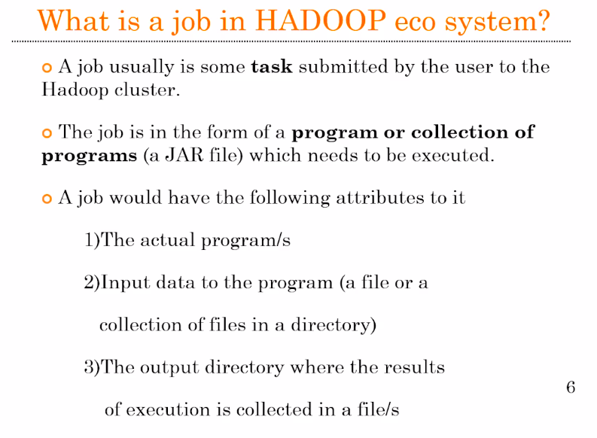
So, when you think of a complex job in a data science, it might involve a set of programs or a single program, which is trying to fetch the data from the hard drive and process it and then you will store the results back into the hard-drive in a file format.

In the Hadoop ecosystem, when we say a job, it’s a collection of programs or single program which is going to run in the cluster and the input data for that particular program is already going be residing in the hard-drive of the data node. So, this data is coming from the distributed file system of hadoop, which is called as HDFS. A typicall job of a hadoop system is consist of a set of programs in the form of JAR file, because the entire Hadoop environment is programmed in Java. Along with the Jar file we have to specify the input file path and the output file path.

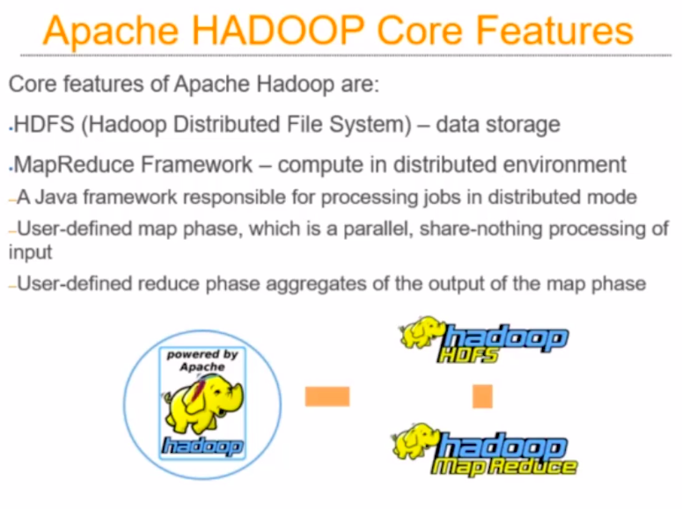
When you try to see Hadoop as a piece of software, there are two major components:
- HDFS (Hadoop Distributed File System)
- MapReduce Framework

HDFS:

HDFS is the common platform for storing and retrieving data.

MapReduce:

Once you have the data in HDFS, you need to process the data , for which you need parallel processing framework. And MapReduce is one such framework, Please note that MapReduce is not the only framework for doing the Parallel Processing. The idea of parallel processing is there from 1970s or 1960s, Hadoop is just one of the parallel processing framework which is use for solving a wide variety of problems.

NOTE: MapReduce is a framwork for Parallel Processing and Hadoop is a Platform for Parallel Processing.

MapReduce is completely written in Java.

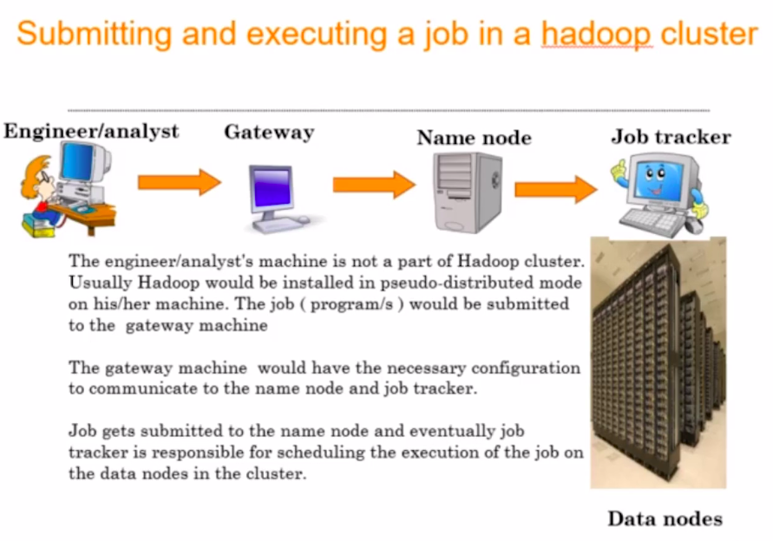
So, how a job is actually submitted to a Hadoop cluster:
When we say a hadoop cluster, we think about the tree master (Name Node, Secondary Node, Job Tracker) and the number of Data Nodes (Slaves). Suppose, you as a analyst/engineer having a piece of program which needs to be executed in a hadoop cluster. Why do you need to execute it in a hadoop cluster, because this cannot be solved on a stand alone system, It’s too slow or it cannot tackle the big data problems.

So you need to make it parallel on a large volume of data, which is now distributed on multiple data nodes. So you as a engineer submit that piece of code or a jar file to the name node. But typically in the production cluster, the ip address and the host name of the name node will not be made available openly, because of security concerns. So we’ll be having another machine in between which is called as a gateway machine, through which you will be able to submit the jobs to the cluster and your name node is going to be the first point of contact in the cluster. Always you are going to speak

to the name node if you wanted to submit a job. This is going to happen through a gateway machine for security reasons.
The gateway machine is not going to be having all the hadoop services running, but it knows how to communicate with the name node and how to communicate with the job tracker. And in fact you will be having the IP address and the access permissions to communicate with the Gateway machine.

Now when you have a job, which is in Java along with the Input File Name which will be present in the hard-drive of the data node, the Name node will be having the information about the location of the file. (Means where the Input file blocks is present). Now, your job tracker is responsible for finding out all these details from the name node, copy your program on to all those data nodes where the corresponding file block of your original file is residing and then start the jobs on each of the data nodes. So the Job Tracker plays the role of a centralized job scheduler. And this is where the Task Tracker actually come into picture. The Task Tracker now monitor the status of the job execution or the status of task status on the individual data nodes and report the status back to the job tracker.

